Mouthguard Policy

WPV Mouthguard Policy

By registering with WPV, players (and if players are under 18 years of age, their parent and legal guardian whose name and details appear on WPV registration documents) agree to abide by the following WPV Mouthguard Policy.

- Acknowledge that Water Polo Victoria has adopted a policy that makes the wearing of mouthguards during matches compulsory or authorised by WPV.
- Acknowledge that they have freely made the decision whether or not to wear a mouthguard.
- Agree to release and forever discharge WPV and any agent or employee or WPV and any other person from and against all claims, actions, suits and demands of every description whatsoever which, but for the execution of this Agreement, I could or might have by reason of or arising out of my decision not to wear a mouthguard during water polo matches.

NARCWPC Mouthguard Policy

The NARCWPC recognises the inherent risk of head trauma, including dental injury and therefore:

- Requires all players to wear a protective mouthguard when participating in activities that involve the potential for contact.
- Requires all coaches to support the policy during NARCWPC training games.
- Requires all referees to support the policy during intra-club games.
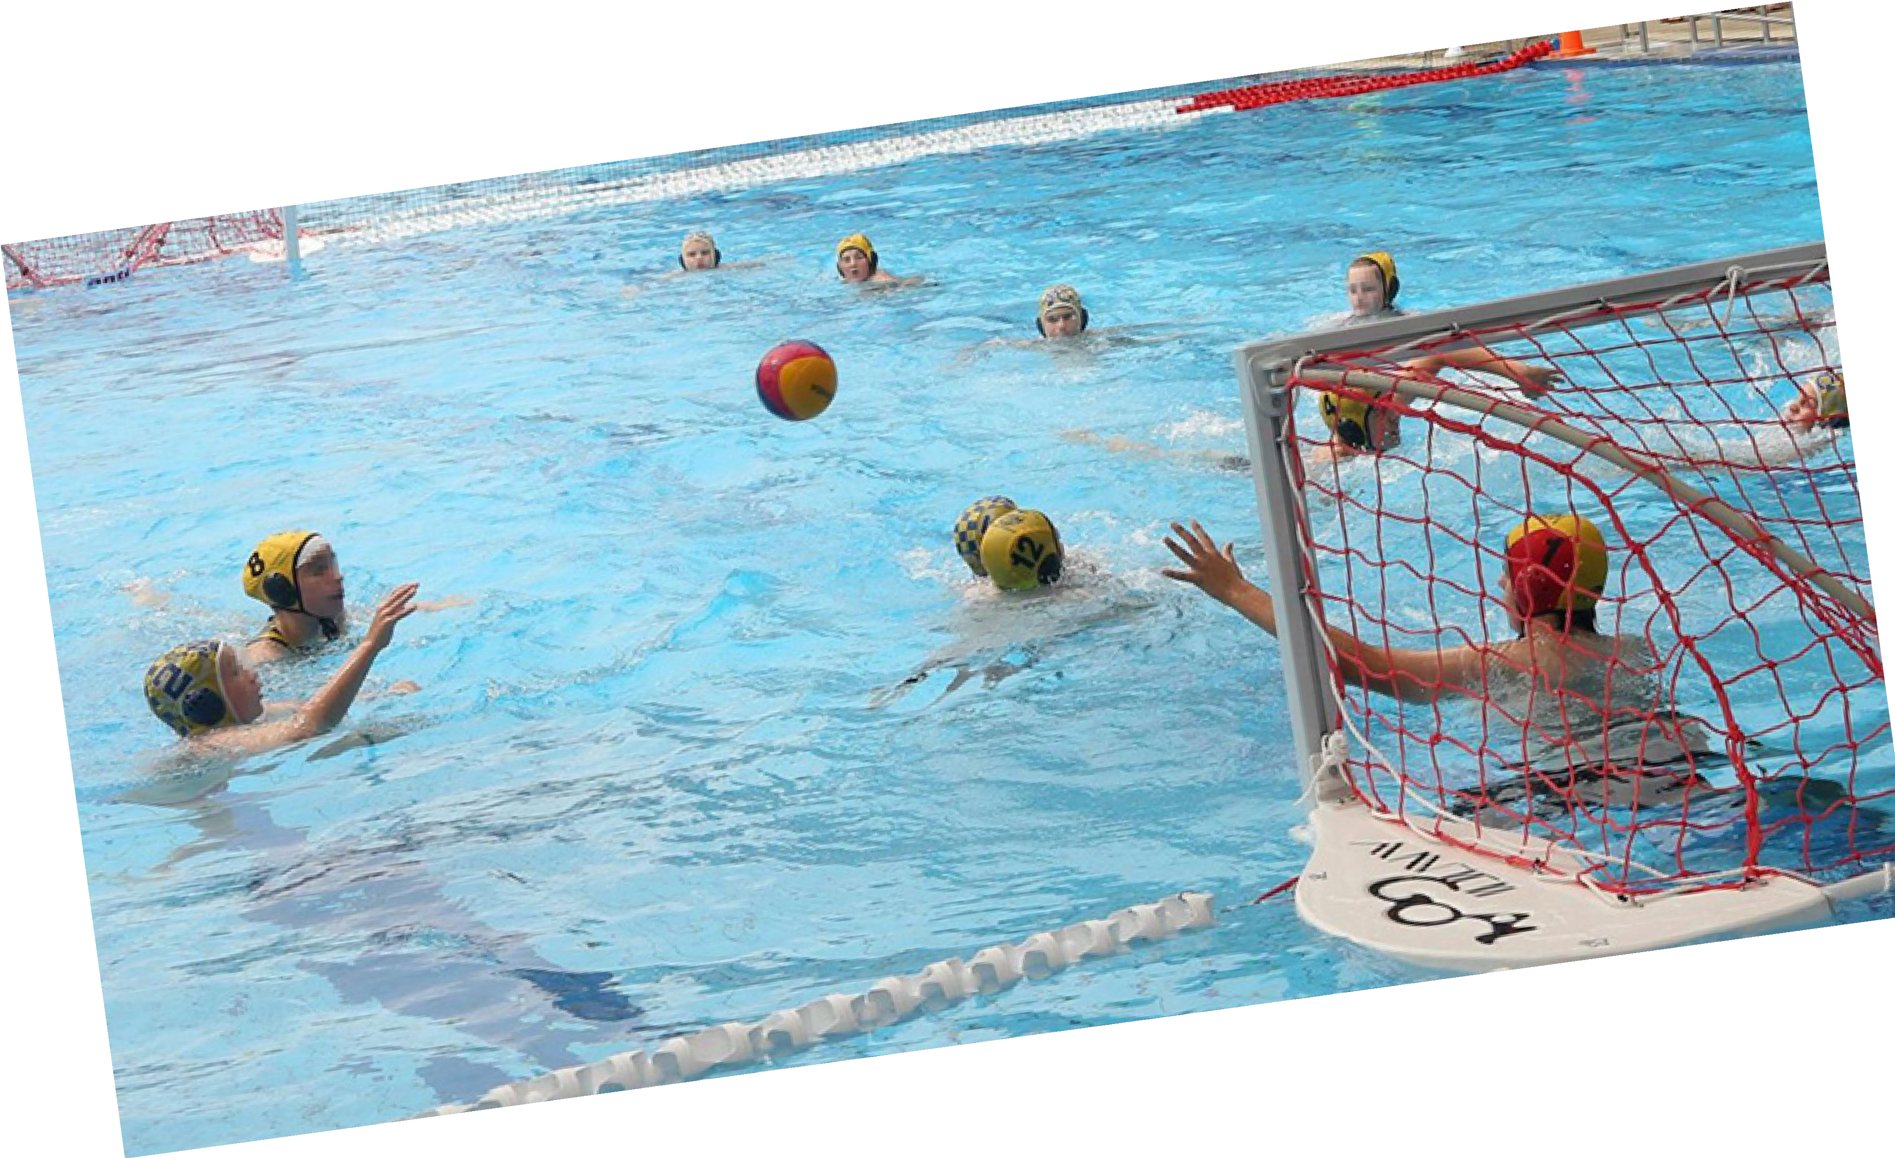
- Provides for exceptions to the policy for those that have voluntarily elected to opt-out of the policy at the time of registration. Junior players will require permission from their parent or legal guardian to opt-out of the policy.

