1. Select the Memberpool login option from WPA homepage
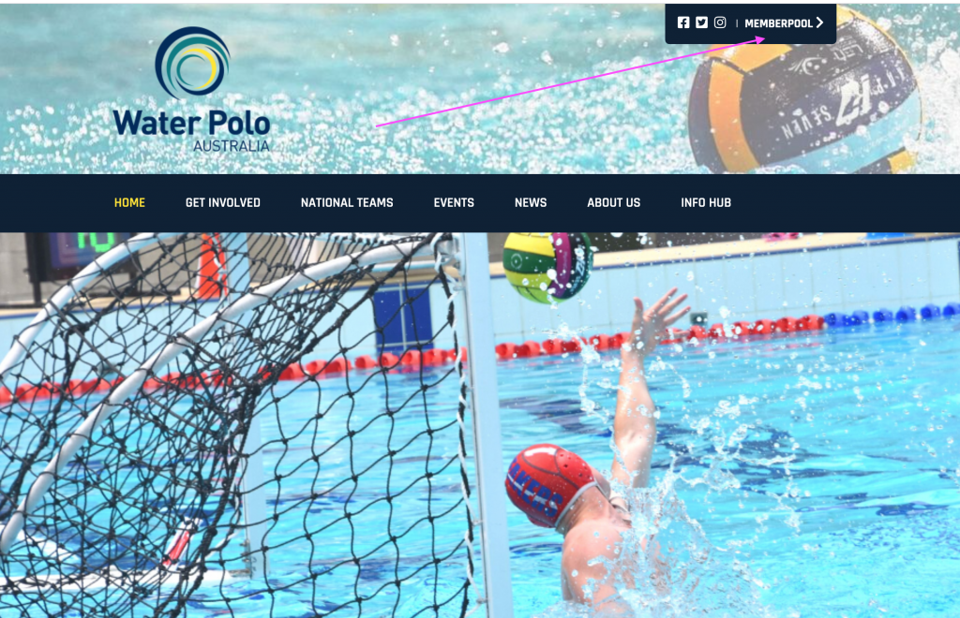

2. Enter your user id and password and login
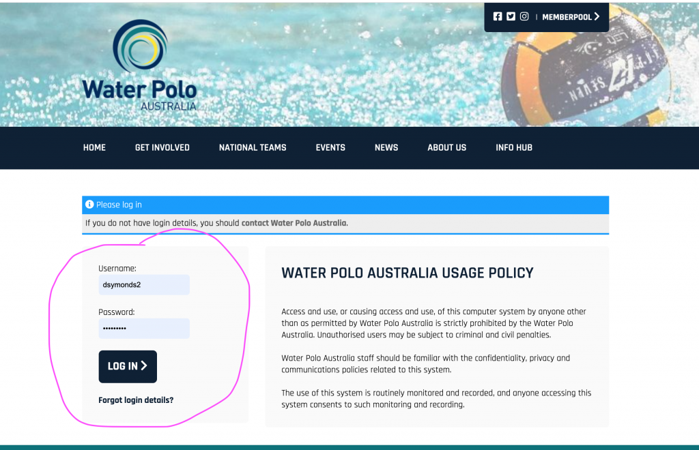

3. Select the LearningPool option
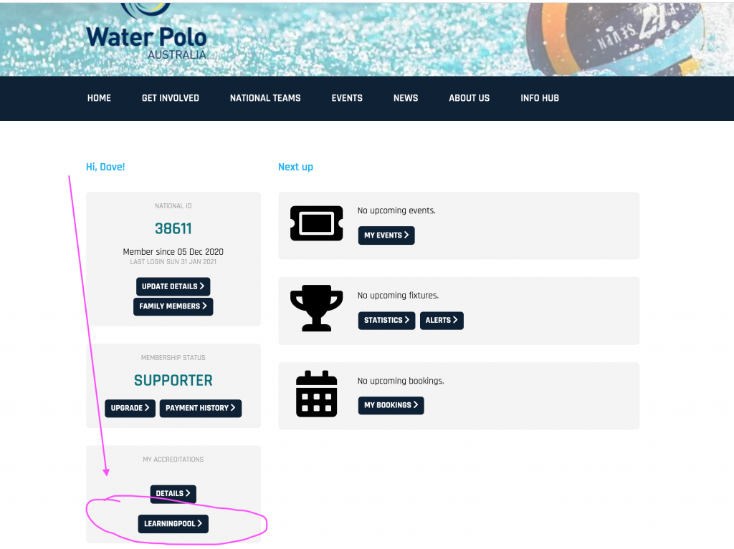

4. Select from the options available - the one for Table training (Competition Official) is shown below in the next image
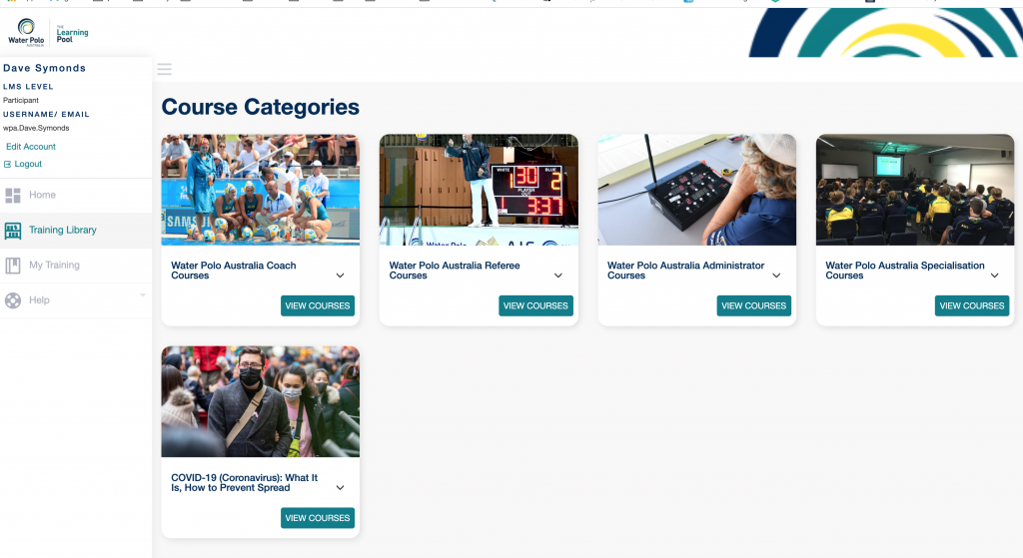

5. Select VIEW and pick your short course and off you go
